CHAPTER 1
INTRODUCTION
1.1 Introduction
An autonomous robot is a robot that is designed and engineered to deal with its environment on its own, and work for extended periods of time without human intervention. Autonomous robots often have sophisticated features that can help them to understand their physical environment and automate parts of their maintenance and direction that used to be done by human hands. Autonomous robots typically go about their work without any human interaction unless that human interaction is necessary as part of their task.
Autonomous robots are intelligent machines capable of performing tasks in the world by themselves, without explicit human control. Examples range from autonomous helicopters to Roomba, the robot vacuum cleaner.

Many tasks which are beyond human ability can be performed with the help of robotics and robotics in the war will be very helpful in its operation. The advancement of robot technology will be amazing and today, robots can be seen virtually in all the fields from transport to health, and recreation to industries. The use of this technology will get proclamations from society for taking away the jobs of an ordinary man. But to solve the issues related to this the usage of robots should be applied to selected tasks and mostly be used in the areas where a human cannot reach or is not capable of performing.
Autonomous vehicle technologies are receiving great attention with increasing demands for autonomy for both civilian and military purposes. In addition, advanced perception techniques and the capability to locate obstacles and targets are necessary to properly operate autonomous systems. Moreover, achieve reliable levels of performance by determining the faults and enabling the system to operate with these faults in mind. Fault tolerance is required to analyze the measured input/output signals of the system.
Autonomous vehicles have become increasingly important assets in various civilian and military operations due to their capability for automatic navigation. These vehicles are able to operate and react to their environment without any outside controls. Autonomous vehicles offer numerous key advantages within the modern world.

1.2 Electrical aspect
There are many types of robots; they are used in many different environments and for many different uses. Although being very diverse in application and form, they all share three basic similarities when it comes to their construction:
- Robots all have some kind of mechanical construction, a frame, form or shape designed to achieve a particular task. For example, a robot designed to travel across heavy dirt or mud, might use caterpillar tracks. The mechanical aspect is mostly the creator's solution to completing the assigned task and dealing with the physics of the environment around it. Form follows function.
- Robots have electrical components that power and control the machinery. For example, the robot with caterpillar tracks would need some kind of power to move the tracker treads. That power comes in the form of electricity, which will have to travel through a wire and originate from a battery, a basic electrical circuit. Even petrol powered machines that get their power mainly from petrol still require an electric current to start the combustion process which is why most petrol powered machines like cars, have batteries. The electrical aspect of robots is used for movement (through motors), sensing (where electrical signals are used to measure things like heat, sound, position, and energy status) and operation (robots need some level of electrical energy supplied to their motors and sensors in order to activate and perform basic operations)
- All robots contain some level of computer programming code. A program is how a robot decides when or how to do something. In the caterpillar track example, a robot that needs to move across a muddy road may have the correct mechanical construction and receive the correct amount of power from its battery, but would not go anywhere without a program telling it to move. Programs are the core essence of a robot, it could have excellent mechanical and electrical construction, but if its program is poorly constructed its performance will be very poor (or it may not perform at all). There are three different types of robotic programs: remote control, artificial intelligence and hybrid. A robot with remote control programming has a preexisting set of commands that it will only perform if and when it receives a signal from a control source, typically a human being with a remote control. It is perhaps more appropriate to view devices controlled primarily by human commands as falling in the discipline of automation rather than robotics. Robots that use artificial intelligence interact with their environment on their own without a control source, and can determine reactions to objects and problems they encounter using their preexisting programming. Hybrid is a form of programming that incorporates both AI and RC functions in them.

CHAPTER 2
LITERATURE SURVEY
The history of robots has its origins in the ancient world. Concepts akin to a robot can be found as long ago as the 4th century BC when the Greek mathematician Archytas of Tarentum postulated a mechanical bird he called “The Pigeon”, which was propelled by steam.
The first electronic autonomous robots with complex behavior were created by William Grey Walter of the Burden Neurological Institute at Bristol, England in 1948 and 1949.
The first digitally operated and programmable robot was invented by George Devol in 1954 and was ultimately called the Unimate. This later laid the foundations of the modern robotics industry. Devol sold the first Unimate to General Motors in 1960, and it was installed in 1961 in a plant in Trenton, New Jersey to lift hot pieces of metal from a die casting machine and stack them. Devol’s patent for the first digitally operated programmable robotic arm represents the foundation of the modern robotics industry.
The first mobile robot capable of reasoning about its surroundings, Shakey, was built in 1970 by the Stanford Research Institute. Shakey combined multiple sensor inputs, including TV cameras, laser rangefinders, and bump sensors to navigate.
The biomimetic robot RoboTuna was built by doctoral student David Barrett at the Massachusetts Institute of Technology in 1996 to study how fish swim in water. RoboTuna is designed to float and to resemble a bluefin tuna.
In 1999, Sony introduced the AIBO, a robotic dog capable of interacting with humans; the first models released in Japan sold out in 20 minutes.
Honda revealed the most advanced result of their humanoid project in 2000, named ASIMO. ASIMO can run, walk, communicate with humans, recognize faces, environment, voices, and posture, and interact with its environment.
The popular Roomba, a robotic vacuum cleaner, was first released in 2002 by the company iRobot.
On October 25, 2017, at the Future Investment Summit in Riyadh, a robot called Sophia was granted Saudi Arabian citizenship, becoming the first robot ever to have a nationality.

CHAPTER 3
Existing and proposed methods
3.1 Existing Method
Line Following is one of the most important aspects of robotics. A Line Following Robot is an autonomous robot which is able to follow either a black or white line that is drawn on the surface consisting of a contrasting color. It is designed to move automatically and follow the made plot line. The robot uses several sensors to identify the line thus assisting the robot to stay on the track. The array of four sensor makes its movement precise and flexible. The robot is driven by DC gear motors to control the movement of the wheels. The Arduino Uno interface is used to perform and implement algorithms to control the speed of the motors, steering the robot to travel along the line smoothly.This project aims to implement the algorithm and control the movement of ther robot by proper tuning of the control parameters and thus achieve better performance.In addition the LCD interface is added in order to display the distance travelled by the robot. It can be used industrial automated equipment carriers, small household applications, tour guides in museums and other similar applications, etc.

3.1.1 Line Follower Robot Circuit
Following is the complete circuit diagram of the line follower robot. Switch can be connected in series with the battery before it provides power to the board and other components of the line follower robot.
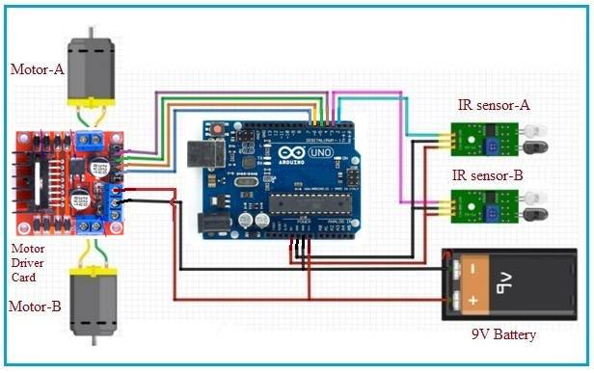
Fig 3.1 : Line Follower Robot Circuit

3.1.2 Line Follower Robot working
IR sensors are used to detect the obstacles. This robot uses IR sensors. This line follower robot is designed to follow the black line by detecting white background and stops when it finds black background. The same is demonstrated in the video below.
IR sensors provide output as zero or one based on presence of obstacle. In this case it provides output based on black or non black (i.e. white) color. When there is black color, output is one and as per arduino code it stops the motor driver output and consecutively motors are OFF. When there is white color in front of IR sensors, output is zero and as per code it generates motor driver output and consecutively motors are ON and robot moves forward due to movement of wheels.

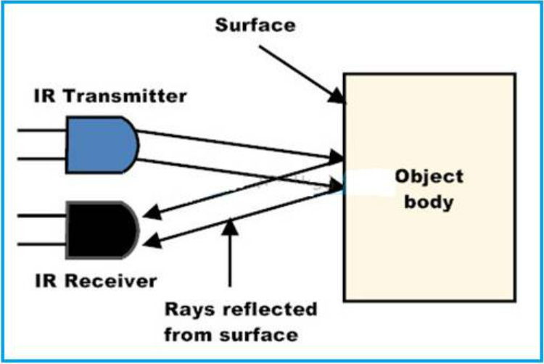
Fig 3.2 : Working of IR Sensor

3.1.3 Code of Line Follower Robot
/*------ Arduino Line Follower Code----- */
/*-------definning Inputs------*/
#define LS 2 // left sensor
#define RS 3 // right sensor
/*-------definning Outputs------*/
#define LM1 4 // left motor
#define LM2 5 // left motor
#define RM1 6 // right motor
#define RM2 7 // right motor
void setup()
{
pinMode(LS, INPUT);
pinMode(RS, INPUT);
pinMode(LM1, OUTPUT);
pinMode(LM2, OUTPUT);
pinMode(RM1, OUTPUT);
pinMode(RM2, OUTPUT);
}
void loop()
{
if(!(digitalRead(LS)) && !(digitalRead(RS))) // Move Forward (digitalRead(LS) && digitalRead(RS))
{
digitalWrite(LM1, HIGH);
digitalWrite(LM2, LOW);
digitalWrite(RM1, HIGH);
digitalWrite(RM2, LOW);
}
if(!(digitalRead(LS)) && digitalRead(RS)) // Turn right
{
digitalWrite(LM1, LOW);
digitalWrite(LM2, LOW);
digitalWrite(RM1, HIGH);
digitalWrite(RM2, LOW);
}
if(digitalRead(LS) && !(digitalRead(RS))) // turn left
{
digitalWrite(LM1, HIGH);
digitalWrite(LM2, LOW);
digitalWrite(RM1, LOW);
digitalWrite(RM2, LOW);
}
if(digitalRead(LS) && digitalRead(RS)) // stop !(digitalRead(LS)) && !(digitalRead(RS))
{
digitalWrite(LM1, LOW);
digitalWrite(LM2, LOW);
digitalWrite(RM1, LOW);
digitalWrite(RM2, LOW);
}
}

3.2 Proposed Method
Proposed method is an advanced version of the existing method. The current method the robot works autonomously with out using using any sensors or navigation system on the robot. The automated guided vehicle runs independently with out any human intervention. A single camera is used on the top of the robot to detect the robot. Here, the on demand technique image processing is used to detect the robot from camera.
We have used python script with open cv to track the robot with colour and used mathematics formulas to triangulate the colour boxes on the robot to find the position and orientation of the robot.
There after we have used the python requests module to send the respective commands to navigate the robot from the pc.
There after we have used the python requests module to send the respective commands to navigate the robot from the pc.
Single camera is used to track the robots
The pc will send the commands to Robot through wifi.
3.2.1 Block Diagram
Camera
Servo Motor
motor
Arduino Uno Wi-Fi Rev2 Board

Laptop
DC Motors
Motor Driver Shield

CHAPTER 3
Major Components Description In This Project

3.1 ARDUINO UNO WI-FI REV 2 BOARD
The Arduino UNO WiFi Rev 2 is the easiest point of entry to basic IoT with the standard form factor of the UNO family. Whether you are looking at building a sensor network connected to your office or home router, or if you want to create a Bluetooth Low Energy device sending data to a cellphone, the Arduino UNO WiFi Rev 2 is your one-stop-solution for many of the basic IoT application scenarios.
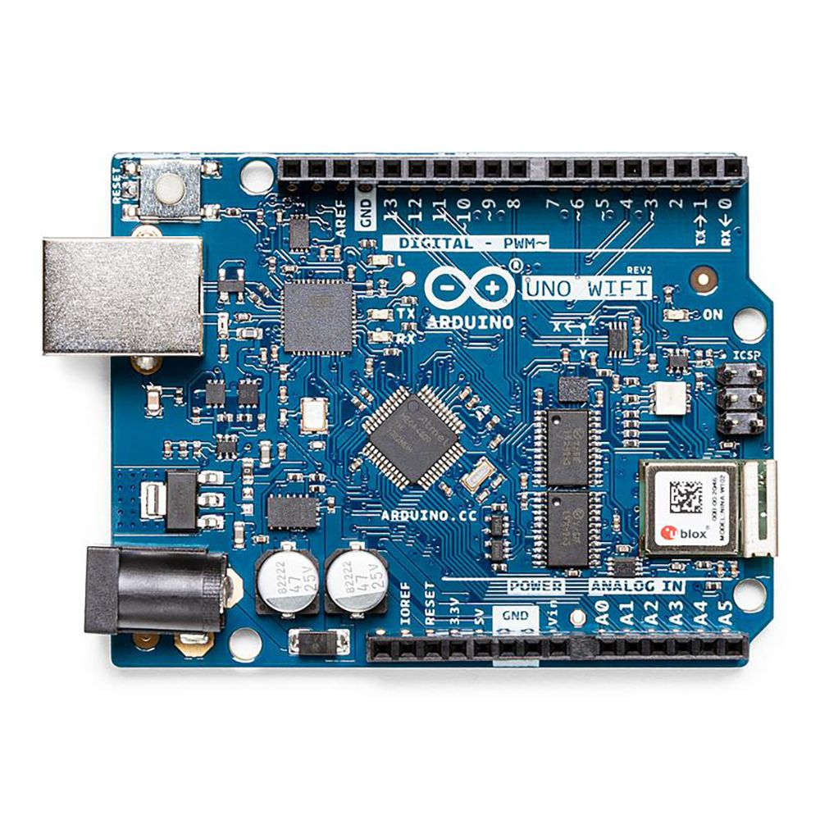
Fig 3.1 : Arduino Uno Wi-Fi Rev 2 Board
Add this board to a device and you'll be able to connect it to a WiFi network, using its secure ECC608 crypto chip accelerator. The Arduino Uno WiFi is functionally the same as the Arduino Uno Rev3, but with the addition of WiFi / Bluetooth and some other enhancements. It incorporates the brand new ATmega4809 8-bit microcontroller from Microchip and has an onboard IMU (Inertial Measurement Unit) LSM6DS3TR.

The Wi-Fi Module is a self-contained SoC with an integrated TCP/IP protocol stack that can provide access to a Wi-Fi network, or act as an access point. Whether you are looking at building a sensor network connected to your office or home router, or if you want to create a

4BLE device sending data to a cellphone, the Arduino UNO WiFi Rev.2 is your one-stop-solution for many of the basic IoT application scenarios.
The Arduino UNO WiFi Rev 2 has 14 digital input/output pins—5 can be used as PWM outputs—6 analog inputs, a USB connection, a power jack, an ICSP header, and a reset button. It contains everything needed to support the microcontroller. Simply connect it to a computer with a USB cable or power it with an AC adapter or battery to get started.

3.1.1 Details
Add this board to a device and you'll be able to connect it to a WiFi network, using its secure ECC608 crypto chip accelerator. The Arduino Uno WiFi is functionally the same as the Arduino Uno Rev3, but with the addition of WiFi / Bluetooth and some other enhancements. It incorporates the brand new ATmega4809 8-bit microcontroller from Microchip and has an onboard IMU (Inertial Measurement Unit) LSM6DS3TR.
The Wi-Fi Module is a self-contained SoC with an integrated TCP/IP protocol stack that can provide access to a Wi-Fi network, or act as an access point.
The Arduino UNO WiFi Rev.2 has 14 digital input/output pins—5 that can be used as PWM outputs—6 analog inputs, a USB connection, a power jack, an ICSP header, and a reset button. It contains everything needed to support the microcontroller. Simply connect it to a computer with a USB cable or power it with an AC adapter or battery to get started.

3.1.1 Specifications
Attribute | Value
Product Name | UNO WiFi Rev 2
Processor Part Number | ATmega4809
Revision | V2

3.1.2 Details Of Arduino Uno Wi-Fi Rev2 Board
Microcontroller | ATmega4809
Operating Voltage | 5V
Input Voltage (Recommended) | 7V – 12V
Digital I/O Pins | 14 – 5 Provide PWM Output
PWM Digital I/O Pins | 5
Analog Input Pins | 6
DC Current Per I/O Pin | 20mA
DC Current For 3.3V Pin | 50mA
Flash Memory | 48 KB (ATmega4809)
SRAM | 6,144 Bytes (ATmega4809)
EEPROM | 256 Bytes (ATmega4809)
Clock Speed | 16 MHz
Radio Module | u-blox NINA-W102
Secure Element | ATECC608A
Internal Measuring Unit | LMS6DS3TR
LED_BUILTIN | 25
Length | 68.8 mm
Width | 53.4 mm
Weight | 25 g

The Arduino Uno WiFi Rev2 is an Arduino Uno with an integrated WiFi module. The board is based on the Microchip MEGA4809 with an ESP32 u-blox NINA-W13 WiFi Module integrated. The NINA-W13 Module is a self-contained SoC with an integrated TCP/IP protocol stack that can give access to your WiFi network (or the device can act as an access point). The Arduino Uno WiFi Rev2 is programmed using the Arduino Software (IDE).

3.1.2 Use your Arduino Uno WiFi Rev2
With the Arduino WiFi Shield, this library allows an Arduino board to connect to the internet and to read and write an SD card using the SD library. It can serve as either a server accepting incoming connections or a client making outgoing ones. The library supports WEP and WPA2 Personal encryption, but not WPA2 Enterprise. The WiFI library is similar to the Ethernet library and many of the function calls are the same.
3.1.3 Applications of Arduino WiFi Shield
1. IOT Applications
2. Robotics
3. Home applications
3.1.4 Arduino IDE
The Arduino integrated development environment (IDE) is a cross-platform application (for Windows, macOS, Linux) that is written in the programming language Java. It is used to write and upload programs to Arduino compatible boards, but also, with the help of 3rd party cores, other vendor development boards.
The source code for the IDE is released under the GNU General Public License, version 2. The Arduino IDE supports the languages C and C++ using special rules of code structuring. The Arduino IDE supplies a software library from the Wiring project, which provides many common input and output procedures. User-written code only requires two basic functions, for starting the sketch and the main program loop, that are compiled and linked with a program stub main() into an executable cyclic executive program with the GNU tool chain, also included with the IDE distribution. The Arduino IDE employs the program argued to convert the executable code into a text file in hexadecimal encoding that is loaded into the Arduino board by a loader program in the board's firmware.

Arduino is a prototype platform (open-source) based on an easy-to-use hardware and software. It consists of a circuit board, which can be programmed (referred to as a microcontroller) and a ready-made software called Arduino IDE (Integrated Development Environment), which is used to write and upload the computer code to the physical board.
Arduino provides a standard form factor that breaks the functions of the micro-controller into a more accessible package.
This tutorial is intended for enthusiastic students or hobbyists. With Arduino, one can get to know the basics of micro-controllers and sensors very quickly and can start building prototype with very little investment.
This tutorial is intended to make you comfortable in getting started with Arduino and its various functions.
Before you start proceeding with this tutorial, we assume that you are already familiar with the basics of C and C++. If you are not well aware of these concepts, then we will suggest you go through our short tutorials on C and C++. A basic understanding of microcontrollers and electronics is also expected.
3.2 Servo Motor
A servomotor is a linear actuator or rotary actuator that allows for precise control of linear or angular position, acceleration, and velocity.. It consists of a motor coupled to a sensor for position feedback. It also requires a servo drive to complete the system. The drive uses the feedback sensor to precisely control the rotary position of the motor. It also requires a relatively sophisticated controller, often a dedicated module designed specifically for use with servomotors.

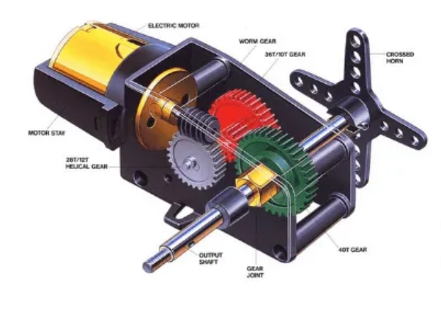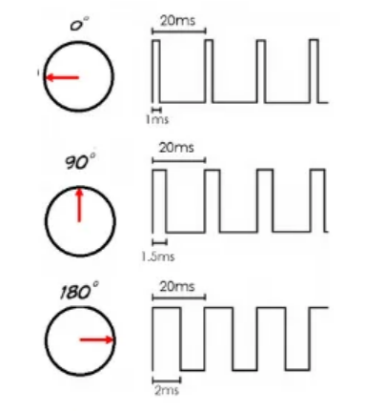
Fig 3.2 : Servo Motor

3.2.1 Servo Motor Theory

There are some special types of applications of an electric motor where the rotation of the motor is required for just a certain angle. For these applications, we require some special types of motor with some special arrangement which makes the motor rotate a certain angle for a given electrical input (signal). For this purpose, servo motor comes into the picture.
The servo motor is usually a simple DC motor controlled for specific angular rotation with the help of additional servomechanism (a typical closed-loop feedback control system). Nowadays, servo systems are used widely in industrial applications.
Servo motor applications are also commonly seen in remote-controlled toy cars for controlling the direction of motion, and it is also very widely used as the motor which moves the tray of a CD or DVD player. Besides these, there are hundreds of servo motor applications we see in our daily life.
The main reason behind using a servo is that it provides angular precision, i.e. it will only rotate as much we want and then stop and wait for the next signal to take further action. The servo motor is unlike a standard electric motor which starts turning as when we apply power to it, and the rotation continues until we switch off the power. We cannot control the rotational progress of electrical motor, but we can only control the speed of rotation and can turn it ON and OFF. Small servo motors are included many beginner Arduino starter kits, as they are easy to operate as part of a small electronics projects.

3.2.2. Servo Motor Working Mechanism
It consists of three parts:
- Controlled device
- Output sensor
- Feedback system
It is a closed-loop system where it uses a positive feedback system to control motion and the final position of the shaft. Here the device is controlled by a feedback signal generated by comparing output signal and reference input signal.
Here reference input signal is compared to the reference output signal and the third signal is produced by the feedback system. And this third signal acts as an input signal to the control the device. This signal is present as long as the feedback signal is generated or there is a difference between the reference input signal and reference output signal. So the main task of servomechanism is to maintain the output of a system at the desired value at presence of noises.
3.2.3 Servo Motor Working Principle
A servo consists of a Motor (DC or AC), a potentiometer, gear assembly, and a controlling circuit. First of all, we use gear assembly to reduce RPM and to increase torque of the motor. Say at initial position of servo motor shaft, the position of the potentiometer knob is such that there is no electrical signal generated at the output port of the potentiometer. Now an electrical signal is given to another input terminal of the error detector amplifier. Now the difference between these two signals, one comes from the potentiometer and another comes from other sources, will be processed in a feedback mechanism and output will be provided in terms of error signal. This error signal acts as the input for motor and motor starts rotating. Now motor shaft is connected with the potentiometer and as the motor rotates so the potentiometer and it will generate a signal. So as the potentiometer’s angular position changes, its output feedback signal changes.

After sometime the position of potentiometer reaches at a position that the output of potentiometer is same as external signal provided. At this condition, there will be no output signal from the amplifier to the motor input as there is no difference between external applied signal and the signal generated at potentiometer, and in this situation motor stops rotating.

3.2.3 Interfacing of Servo Motor With Microcontrollers
Interfacing hobby Servo motors like s90 servo motor with MCU is very easy. Servos have three wires coming out of them. Out of which two will be used for Supply (positive and negative) and one will be used for the signal that is to be sent from the MCU. An MG995 Metal Gear Servo Motor which is most commonly used for RC cars humanoid bots etc. The picture of MG995 is shown below:
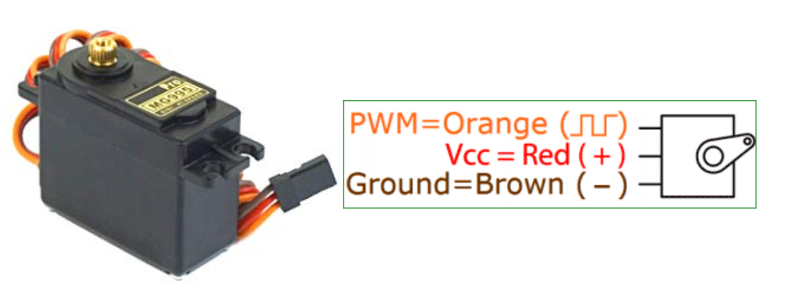
Fig 3.3 : Connections of Servo Motor
The color coding of your servo motor might differ hence check for your respective datasheet.
All servo motors work directly with your +5V supply rails but we have to be careful on the amount of current the motor would consume if you are planning to use more than two servo motors a proper servo shield should be designed.
3.2.4 Controlling of Servo Motor
All motors have three wires coming out of them. Out of which two will be used for Supply (positive and negative) and one will be used for the signal that is to be sent from the MCU.
Servo motor is controlled by PWM (Pulse with Modulation) which is provided by the control wires. There is a minimum pulse, a maximum pulse and a repetition rate. Servo motor can turn 90 degree from either direction form its neutral position. The servo motor expects to see a pulse every 20 milliseconds (ms) and the length of the pulse will determine how far the motor turns. For example, a 1.5ms pulse will make the motor turn to the 90° position, such as if pulse is shorter than 1.5ms shaft moves to 0° and if it is longer than 1.5ms than it will turn the servo to 180°.
Servo motor works on PWM (Pulse width modulation) principle, means its angle of rotation is controlled by the duration of applied pulse to its Control PIN. Basically servo motor is made up of DC motor which is controlled by a variable resistor (potentiometer) and some gears. High speed force of DC motor is converted into torque by Gears. We know that WORK= FORCE X DISTANCE, in DC motor Force is less and distance (speed) is high and in Servo, force is High and distance is less. The potentiometer is connected to the output shaft of the Servo, to calculate the angle and stop the DC motor on the required angle.
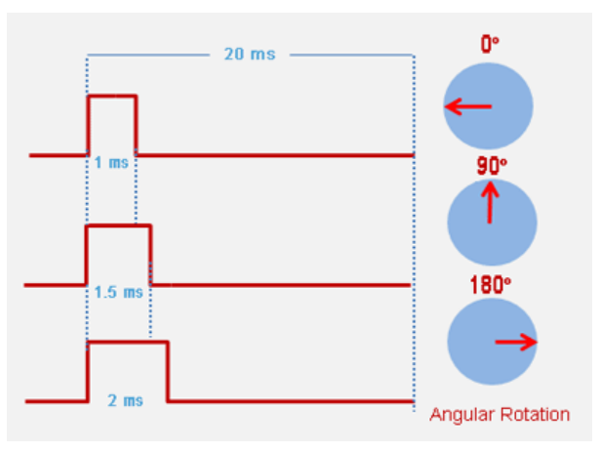
Fig 3.4 : Controlling of Servo Motor
Servo motor can be rotated from 0 to 180 degrees, but it can go up to 210 degrees, depending on the manufacturing. This degree of rotation can be controlled by applying the Electrical Pulse of proper width, to its Control pin. Servo checks the pulse in every 20 milliseconds. The pulse of 1 ms (1 millisecond) width can rotate the servo to 0 degrees, 1.5ms can rotate to 90 degrees (neutral position) and 2 ms pulse can rotate it to 180 degree.

All servo motors work directly with your +5V supply rails but we have to be careful about the amount of current the motor would consume if you are planning to use more than two servo motors a proper servo shield should be designed.
3.3 Webcam
A webcam is a video camera that feeds or streams an image or video in real time to or through a computer network, such as the Internet. Webcams are typically small cameras that sit on a desk, attach to a user's monitor, or are built into the hardware. Webcams can be used during a video chat session involving two or more people, with conversations that include live audio and video.
Webcam software enables users to record a video or stream the video on the Internet. As video streaming over the Internet requires much bandwidth, such streams usually use compressed formats. The maximum resolution of a webcam is also lower than most handheld video cameras, as higher resolutions would be reduced during transmission. The lower resolution enables webcams to be relatively inexpensive compared to most video cameras, but the effect is adequate for video chat sessions.^{[1]}
The term "webcam" (a clipped compound) may also be used in its original sense of a video camera connected to the Web continuously for an indefinite time, rather than for a particular session, generally supplying a view for anyone who visits its web page over the Internet. Some of them, for example, those used as online traffic cameras, are expensive, rugged professional video cameras.

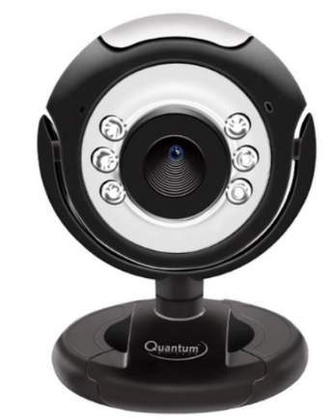
Fig 3.5 : Quantum QHM495LM 6 light webcam
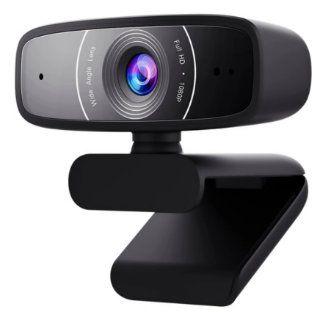
Fig 3.6 : ASUS Webcam C3
3.3.1 Technology
Webcams typically include a lens, an image sensor, support electronics, and may also include one or even two microphones for sound.
3.3.1.1 Image Sensor
Image sensors can be CMOS or CCD, the former being dominant for low-cost cameras, but CCD cameras do not necessarily outperform CMOS-based cameras in the low-price range. Most consumer webcams are capable of providing VGA-resolution video at a frame rate of 30 frames per second. Many newer devices can produce video in multi-megapixel resolutions, and a few can run at high frame rates such as the PlayStation Eye, which can produce 320×240 video at 120 frames per second. The Wii Remote contains an image sensor with a resolution of 1024×768 pixels. Common resolutions of laptops' built-in webcams are 720p (HD), and in lower-end laptops 480p.^{[2]} The earliest known laptops with 1080p (Full HD) webcams like the Samsung 700G7C were released in the early 2010s.^{[3]}
As the bayer filter is proprietary, any webcam contains some built-in image processing, separate from compression.
3.3.1.2 Optics
Various lenses are available, the most common in consumer-grade webcams being a plastic lens that can be manually moved in and out to focus the camera. Fixed-focus lenses, which have no provision for adjustment, are also available.

As a camera system's depth of field is greater for small image formats and is greater for lenses with a large f-number (small aperture), the systems used in webcams have a sufficiently large depth of field that the use of a fixed-focus lens does not impact image sharpness to a great extent. Most models use simple, focal-free optics (fixed focus, factory-set for the usual distance from the monitor to which it is fastened to the user) or manual focus.
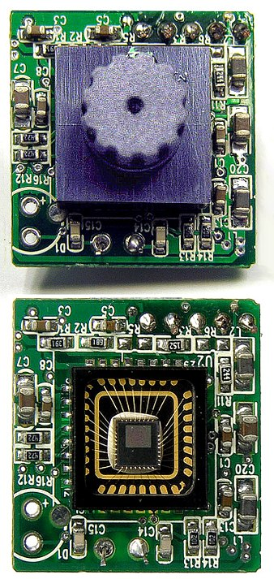
Fig 3.7 : Components of any webcam : Image sensor, lens and supporting circuitry.
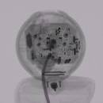
Fig 3.8 : Animated set of X-ray images of a webcam. Images acquired using industrial CT scanning.

3.3.1.3 Compression
Digital video streams are represented by huge amounts of data, burdening its transmission (from the image sensor, where the data is continuously created) and storage alike.
Most if not all cheap webcams come with built-in ASIC to do video compression in real-time.
Support electronics read the image from the sensor and transmit it to the host computer. The camera pictured to the right, for example, uses a Sonix SN9C101 to transmit its image over USB. Typically, each frame is transmitted uncompressed in RGB or YUV or compressed as JPEG. Some cameras, such as mobile-phone cameras, use a CMOS sensor with supporting electronics "on die", i.e. the sensor and the support electronics are built on a single silicon chip to save space and manufacturing costs. Most webcams feature built-in microphones to make video calling and videoconferencing more convenient.
3.3.1.4 Interface
Typical interfaces used by articles marketed as a "webcam" are USB, Ethernet and IEEE 802.11 (denominated as IP camera). Further interfaces such as e.g. Composite video, S-Video or FireWire were also available.
The USB video device class (UVC) specification allows inter-connectivity of webcams to computers without the need for proprietary device drivers.
3.3.1.5 Software
Various proprietary as well as free and open-source software is available to handle the UVC stream. One could use Guvcview or GStreamer and GStreamer-based software to handle the UVC stream. Another could use multiple USB cameras attached to the host computer the software resides on, and broadcast multiple streams at once over (Wireless) Ethernet, such as MotionEye. MotionEye can either be installed onto a Raspberry Pi as MotionEyeOs, or afterwards on Raspbian as well. MotionEye can also be set up on Debian, Raspbian is a variant of Debian. Note that MotionEye V4.1.1 ( Aug '21 ) can only run on Debian 10 Buster ( oldstable ) and Python 2.7. Newer versions such as 3.X are not supported at this point of time according to Ccrisan, foundator and author of MotionEye.

3.3.2 Characterstics
Webcams are known for their low manufacturing cost and their high flexibility,^{[4]} making them the lowest-cost form of videotelephony. As webcams evolved simultaneously with display technologies, USB interface speeds and broadband internet speeds, the resolution went up from gradually from 320×240, to 640×480, and some now even offer 1280×720 (aka 720p) or 1920×1080 (aka 1080p) resolution.^{[5][6][7]}
Webcams can come with different presets and Fields of View (FOV). Individual users can make use of less than 90° Horizontal FOV for home offices and live streaming. Webcams with as much as 360° Horizontal FOV can be used for small- to medium- sized rooms (sometimes even large rooms). Depending on the users' purposes, webcams in the market can display the whole room or just the general vicinity.
Despite the low cost, the resolution offered as of 2019 is impressive, with now the low-end webcams offering resolutions of 720p, mid-range webcams offering 1080p resolution, and high-end webcams offering 4K resolution at 60 fps.
Webcams have become a source of security and privacy issues, as some built-in webcams can be remotely activated by spyware. To address this concern, many webcams come with a physical lens cover.
3.3.3 Uses
The most popular use of webcams is the establishment of video links, permitting computers to act as videophones or videoconference stations. For example, Apple's iSight camera, which is built into Apple laptops, iMacs and a majority of iPhones, can be used for video chat sessions, using the Messages instant messaging program. Other popular uses include security surveillance, computer vision, video broadcasting, and for recording social videos.
The video streams provided by webcams can be used for a number of purposes, each using appropriate software.

3.3.3.1 Video monitoring
Webcams may be installed at places such as childcare centres, offices, shops and private areas to monitor security and general activity.

3.3.3.2 Commerce
Webcams have been used for augmented reality experiences online. One such function has the webcam act as a "magic mirror" to allow an online shopper to view a virtual item on themselves. The Webcam Social Shopper is one example of software that utilizes the webcam in this manner.

3.3.3.3 Videocalling and videoconferencing
Webcams can be added to instant messaging, text chat services such as AOL Instant Messenger, and VoIP services such as Skype, one-to-one live video communication over the Internet has now reached millions of mainstream PC users worldwide. Improved video quality has helped webcams encroach on traditional video conferencing systems. New features such as automatic lighting controls, real-time enhancements (retouching, wrinkle smoothing and vertical stretch), automatic face tracking and autofocus, assist users by providing substantial ease-of-use, further increasing the popularity of webcams.
Since the middle of 2020, remote and hybrid work has increased the popularity of webcams. Businesses, schools, and individuals have relied on video conferencing instead of spending on business travel for meetings. Moreover, the number of video conferencing cameras and software have multiplied since then due to their popularity.
Webcam features and performance can vary by program, computer operating system, and also by the computer's processor capabilities. Video calling support has also been added to several popular instant messaging programs.

3.3.3.4 Video security
Webcams can be used as security cameras. Software is available to allow PC-connected cameras to watch for movement and sound, recording both when they are detected. These recordings can then be saved to the computer, e-mailed, or uploaded to the Internet. In one well-publicised case, a computer e-mailed images of the burglar during the theft of the computer, enabling the owner to give police a clear picture of the burglar's face even after the computer had been stolen.
Unauthorized access of webcams can present significant privacy issues (see "Privacy" section below).
In December 2011, Russia announced that 290,000 Webcams would be installed in 90,000 polling stations to monitor the 2012 Russian presidential election.

3.3.3.5 Video clips and stills
Webcams can be used to take video clips and still pictures. Various software tools in wide use can be employed for this, such as PicMaster and Microsoft's Camera app (for use with Windows operating systems), Photo Booth (Mac), or Cheese (with Unix systems). For a more complete list see Comparison of webcam software.

3.3.3.6 Input control devices
Special software can use the video stream from a webcam to assist or enhance a user's control of applications and games. Video features, including faces, shapes, models and colors can be observed and tracked to produce a corresponding form of control. For example, the position of a single light source can be tracked and used to emulate a mouse pointer, a head-mounted light would enable hands-free computing and would greatly improve computer accessibility. This can be applied to games, providing additional control, improved interactivity and immersiveness.
FreeTrack is a free webcam motion-tracking application for Microsoft Windows that can track a special head-mounted model in up to six degrees of freedom and output data to mouse, keyboard, joystick and FreeTrack-supported games. By removing the IR filter of the webcam, IR LEDs can be used, which has the advantage of being invisible to the naked eye, removing a distraction from the user. TrackIR is a commercial version of this technology.
The EyeToy for the PlayStation 2, PlayStation Eye for the PlayStation 3, and the Xbox Live Vision camera and Kinect motion sensor for the Xbox 360 and are color digital cameras that have been used as control input devices by some games.
Small webcam-based PC games are available as either standalone executables or inside web browser windows using Adobe Flash.

3.3.3.7 Astro photography

With very-low-light capability, a few specific models of webcams are very popular to photograph the night sky by astronomers and astro photographers. Mostly, these are manual-focus cameras and contain an old CCD array instead of comparatively newer CMOS array. The lenses of the cameras are removed and then these are attached to telescopes to record images, video, still, or both. In newer techniques, videos of very faint objects are taken for a couple of seconds and then all the frames of the video are "stacked" together to obtain a still image of respectable contrast.

3.3.3.8 Laser beam profiling

A webcam's CCD response is linear proportional to the incoming light. Therefore, webcams are suitable to record laser beam profiles, after the lens is removed. The resolution of a laser beam profiler depends on the pixel size. Commercial webcams are usually designed to record color images. The size of a webcam's color pixel depends on the model and may lie in the range of 5 to 10 µm. However, a color pixel consists of four black and white pixels each equipped with a color filter (for details see Bayer filter). Although these color filters work well in the visible, they may be rather transparent in the near infrared. By switching a webcam into the Bayer-mode it is possible to access the information of the single pixels and a resolution below 3 µm was possible.
3.3.4 History

Early development (Early 1990s)
First developed in 1991, a webcam was pointed at the Trojan Room coffee pot in the Cambridge University Computer Science Department (initially operating over a local network instead of the web). The camera was finally switched off on August 22, 2001. The final image captured by the camera can still be viewed at its homepage. The oldest continuously operating webcam, San Francisco State University's FogCam, has run since 1994 and was slated to turn off August 2019. It updates every 20 seconds.^{[16]} After the publicity following extensive news coverage about the planned ending of FogCam, SFSU agreed to continue maintaining the FogCam and keep it running.

IndyCam

The released in 1993 SGI Indy is the first commercial computer to have a standard video camera, and the first SGI computer to have standard video inputs.
The maximum supported input resolution is 640×480 for NTSC or 768×576 for PAL. A fast machine is required to capture at either of these resolutions, though; an Indy with slower R4600PC CPU, for example, may require the input resolution to be reduced before storage or processing. However, the Vino hardware is capable of DMAing video fields directly into the framebuffer with minimal CPU overhead.

Commercial webcam (Mid 90s)

Connectix QuickCam

The first widespread commercial webcam, the black-and-white QuickCam, entered the marketplace in 1994, created by the U.S. computer company Connectix. QuickCam was available in August 1994 for the Apple Macintosh, connecting via a serial port, at a cost of $100. Jon Garber, the designer of the device, had wanted to call it the "Mac-camera", but was overruled by Connectix's marketing department; a version with a PC-compatible parallel port and software for Microsoft Windows was launched in October 1995. The original QuickCam provided 320x240-pixel resolution with a grayscale depth of 16 shades at 60 frames per second, or 256 shades at 15 frames per second.^{[21]} These cam were tested on several Delta II launch using a variety of communication protocols including CDMA, TDMA, GSM and HF.
In 2010, Time Magazine named the QuickCam as one of the top computer devices of all time.^{[22]}
Videoconferencing via computers already existed, and at the time client-server based videoconferencing software such as CU-SeeMe had started to become popular.

RS/6000 integrated webcam

The first widely known laptop with integrated webcam option, at a pricepoint starting at US$ 12,000, was an IBM RS/6000 860 laptop and his ThinkPad 850 sibling, released in 1996.

Entering the mainstream (Late 90s - 2000s)

One of the most widely reported-on webcam sites was JenniCam, created in 1996, which allowed Internet users to observe the life of its namesake constantly, in the same vein as the reality TV series Big Brother, launched four years later. Other cameras are mounted overlooking bridges, public squares, and other public places, their output made available on a public web page in accordance with the original concept of a "webcam". Aggregator websites have also been created, providing thousands of live video streams or up-to-date still pictures, allowing users to find live video streams based on location or other criteria.
In the late 1990s, Microsoft NetMeeting was the only videoconferencing software on PC in widespread use, making use of webcams. In the following years, instant messaging clients started adding webcam support: Yahoo Messenger introduced this with version 5.5 in 2002, allowing video calling in 20 frames per second using a webcam. MSN Messenger gained this in version 5.0 in 2003.
Around the turn of the 21st century, computer hardware manufacturers began building webcams directly into laptop and desktop screens, thus eliminating the need to use an external USB or FireWire camera. Gradually webcams came to be used more for telecommunications, or videotelephony, between two people, or among several people, than for offering a view on a Web page to an unknown public.

Later developments (2010s - Present)

For less than US$100 in 2012, a three-dimensional space webcam became available, producing videos and photos in 3D anaglyph image with a resolution up to 1280 × 480 pixels. Both sender and receiver of the images must use 3D glasses to see the effect of three dimensional image.

Webcams are considered an essential accessory for remote work, mainly to compensate for lower quality video processing with the built-in camera of the average laptop. During the COVID-19 pandemic, there was a shortage of webcams. Most laptops before and during the pandemic were made with cameras capping out at 720p recording quality at best, compared to the industry standard of 1080p or 4K seen in smartphones and televisions from the same period. The backlog on new developments for built-in webcams is the result of a design flaw with laptops being too thin to support the 7mm camera modules to fit inside, instead resorting to ~2.5mm. Also the camera components are more expensive and not a high level of demand for this feature, companies like Apple have not updated their webcams since 2012.^{[35]} Smartphones started to be used as a backup option or webcam replacement, with kits including lighting and tripods or downloadable apps.

4.4 DC Motor
A DC motor or direct current motor is an electrical machine that transforms electrical energy into mechanical energy by creating a magnetic field that is powered by direct current. When a DC motor is powered, a magnetic field is created in its stator. The field attracts and repels magnets on the rotor; this causes the rotor to rotate. To keep the rotor continually rotating, the commutator that is attached to brushes connected to the power source supply current to the motors wire windings.
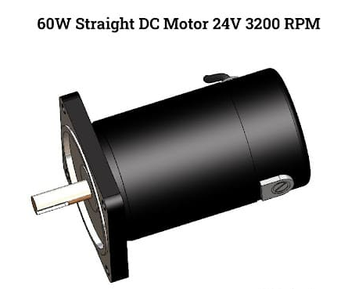
Fig : DC Motor

One of the reasons DC motors are preferred over other types of motors is their ability to precision control their speed, which is a necessity for industrial machinery. DC motors are able to immediately start, stop, and reverse—an essential factor for controlling the operation of production equipment.
4.4.1 Types of DC Motor
In order to appreciate the benefits of DC motors, it is important to understand the various types. Each type of DC motor has beneficial characteristics that must be examined before purchase and use. Two of the main advantages of DC motors over alternating current (AC) motors are how easy they are to install and that they require little maintenance.
DC motors are differentiated by the connections between the field winding and the armature. The field winding can be connected parallel to the armature or connected in a series. In some cases, the connection is both parallel and in a series.
A further distinction of DC motors is how the rotor is powered; it can be brushed or brushless. In brush DC motors, current is applied to the rotor by brushes. In a brushless DC motor, the rotor has a permanent magnet.
Since DC motors are everywhere and used for a wide variety of applications, there is a different type to meet the needs of every application. Regardless of your need for DC motors, it is important to understand each type since they can be found in every aspect of life.
Brushed DC Motor
The magnetic field in a brush DC motor is produced by current sent through a commutator and brush that are connected to the rotor. Brushes are made of carbon and can be separately excited or self excited. The stator is the enclosure that contains the components of the motor and contains the magnetic field.
The winding of the coil on the rotor can be in a series or parallel to form either a series wound DC motor or shunt wound DC motor.
The commutator is an electrical switch that reverses the current between the rotor and the external power source. It is a method of applying electrical current to the windings and produces a steady rotating torque by reversing the current direction. The sections of the commutator are attached to the windings on the rotor through a set of contact bars that are set in the shaft of the motor.
There are three main types of DC motors: separately excited, self excited, or permanent magnet. In the separately excited and self excited, an electromagnet is used in the stator structure. With the permanent magnet type, a powerful magnet generates the magnetic field.
Self excited DC motors are further divided into shunt, series, and compound. The compound excited type is separated into cumulative and differential with short and long shunts in each type.
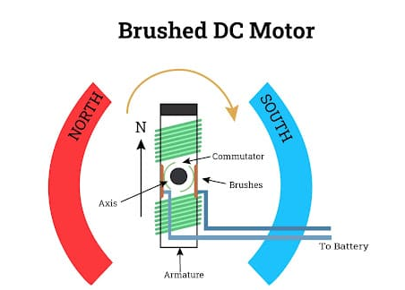
Fig : Brushed DC Motor
Separately Excited DC Motor
In a separately excited DC motor, the motor has separate electrical supplies to the armature winding and field winding, which are electrically separate from each other.
The operations of the armature current and field current do not interfere with each other‘s actions, but the input power is their total sum.
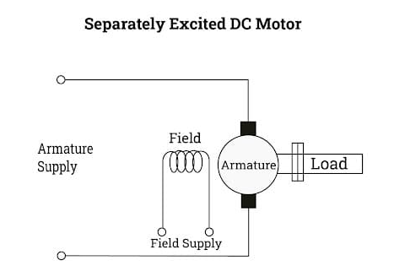
Fig : Separately Excited DC Motor
Permanent Magnet DC Motor
A permanent magnet DC motor has an armature winding but does not have a field winding. The permanent magnet is mounted on the inner surface of the stator core to produce the magnetic field. It has a regular armature consisting of a commutator and brushes.
Permanent magnet DC motors are smaller and less expensive. They use rare earth magnets such as samarium cobalt or neodymium iron boron.
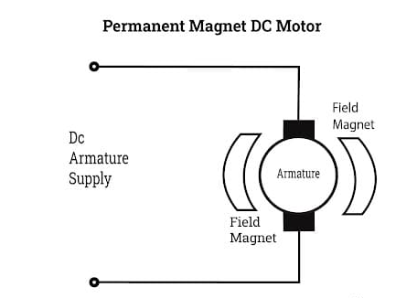
Fig : Permanent Magnet DC Motor
Self Excited DC Motor
In self excited DC motors, the field and armature windings are connected and have a single supply source. The connections are parallel or series with parallel made as shunt wound while the series version is series wound.
Shunt
In a shunt wound DC motor, the field and armature windings are connected parallel to each other; this exposes the field winding to terminal voltage. Though the supply is the same, the current for the field and armature windings is different. The speed of a shunt DC motor is constant and does not deviate with varying mechanical loads.
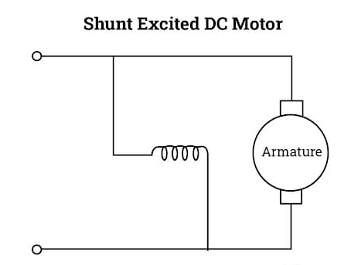
Fig : Shunt Excited DC Motor
Series
The field and armature winding on a series DC motor are connected to the power supply in a series. The same current flows in the field and armature windings. A series wound motor can work with AC and DC voltage supply, which makes it a universal motor.
Series motors always rotate in the same direction regardless of the voltage source. Their speed varies with the mechanical load.
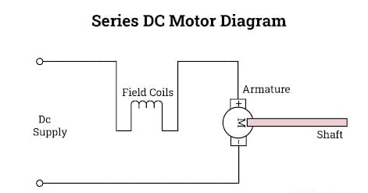
Fig : Series DC Motor
Compound
A compound DC motor uses the features of the series and shunt field windings. The winding for the armature is connected in a series while the winding for the field is a shunt or parallel connection.
Compound DC motors are further divided into cumulative and differential. With cumulative DC motors, the flux of the shunt field helps the flux in the series field. They both move in the same direction while the flux of a differential compound DC motor, for the series and shunt fields, moves in the opposite direction. Cumulative and differential compound DC motors can have long or short shunts; this is based on the shunting of the shunt field winding.
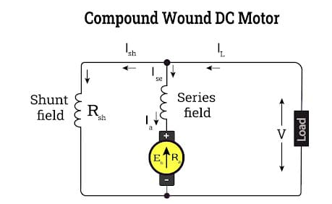
Fig : Compound wound DC Motor

Brushless DC Motor
Brushless DC motors have a permanent magnet rotor and a coil wound stator. This design of DC motor removes the need for brushes. The benefit of a brushless DC motor is the elimination of wear and tear of brushes since very little heat is produced by the rotating magnet. The efficiency of brushless DC motors makes them more expensive.
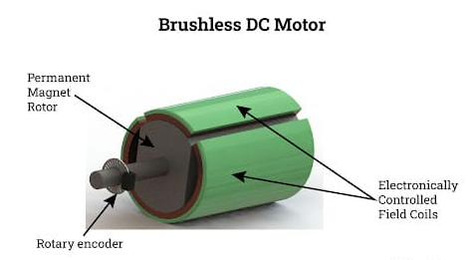
Fig : Brushless DC Motor
Servo DC Motor
A servo DC motor has four parts: a DC motor, gearbox, control circuit, and position sensing unit. The gearbox changes high speed input into slower practical speed. The control circuit is an error detector amplifier. The position of the shaft gives feedback to the control circuit and is in a closed loop. With a servo DC motor, if there is any mismatch between the current position of the shaft and its reference position, an error signal is sent to the error detecting amplifier.
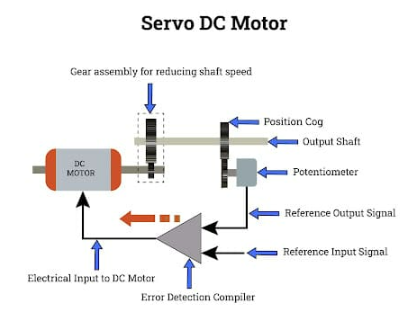
Fig : Servo DC Motor
4.4.2 Working of DC Motor
A DC motor is based on the idea that when a current carrying conductor is placed in a magnetic field, it produces mechanical force. The direction of the force is determined by the left hand rule. Since DC motors and DC generators have the same construction, they can be used interchangeably.
For large electrical applications, such as steel mills and electric trains, alternating current (AC) is converted into DC current since the speed and torque characteristics of a DC motor are superior to an AC motor. In the case of industrial applications, DC motors are as widely used as three phase induction motors.
Stator
The stator is the unmoving main body of the motor, and it provides support and protection for the motor. The stator provides a rotating magnetic field that drives the armature or rotor. It is the static part of the motor that houses the field windings and receives the electrical supply through its terminals.
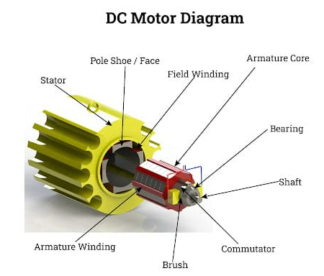
Fig : DC Motor Diagram

Shaft
The windings and the commutator rotate the shaft, which is at the center of the motor and made of a hardened metal, usually steel, to withstand the loads of the application. The commutator bars are attached to the plate that is affixed to the shaft by plastic molding. The torque that is produced by the winding is transferred to the shaft supported by the stator. The shaft protrudes through the stator and connects the motor to the application.
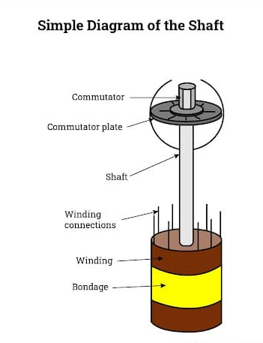
Fig : Simple Diagram of the Shaft
Terminals
A DC motor has two terminals: positive and negative. When the positive wire is connected to the positive terminal and the negative wire connected to the negative terminal, the motor rotates clockwise. When they are reversed, the motor rotates counter clockwise. The terminals provide the power supply for the motor and are connected to the brushes and brush arms inside the back cover.
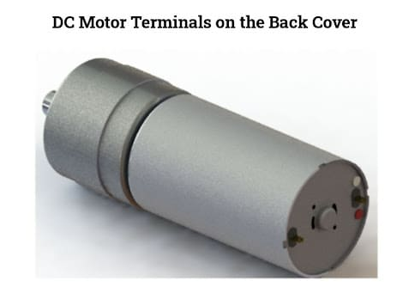
Fig : DC Motor Terminals
Magnets
The magnets used in DC motors are referred to as permanent magnets; this means their magnetic field is always active. Opposite ends of magnets attract while similar ends repel. The magnetic field of a magnet runs from the south pole to the north pole. The most powerful part of a magnet‘s magnetic field is at its ends.
Two magnets create a very strong field; this is why two magnets are included in a DC motor around the rotor such that the strong magnetic field passes through the rotor.
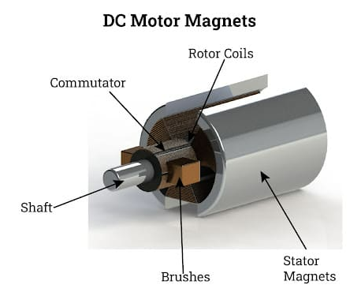
Fig : DC Motor Magnets

Rotor
The rotor or armature is made of multiple disks that are insulated from each other by laminated sheets. The multiple disks prevent the creation of a large eddy current. (Eddy currents are the reason the plates are insulated.) Eddy currents are still present but are much smaller and do not interfere with the operation of the motor; they are a necessary part of the motor's operation. For greater motor efficiency, the disks of the rotor are made as small as possible. The rotor is the dynamic part of the motor that is used to create the mechanical revolutions.
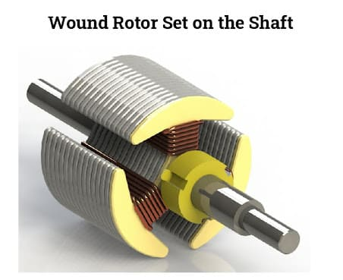
Fig : Wound Rotor set on the shaft
Coil Windings
The coil windings are wrapped around the rotor. The coiling of the wire creates a strong and powerful magnetic field. Every type of wire creates a weak magnetic field when electricity passes through it. Due to coiling of the wire, each turned section has the same weak magnetic field. When combined with all the different coiled wire, a strong magnetic field is created. As more coils are added to the rotor, its rotation becomes smoother. All DC motors have a minimum of three coils to ensure smooth rotation since two coils tend to jam and stop the motor. Each coil is 120o from the previous coil.

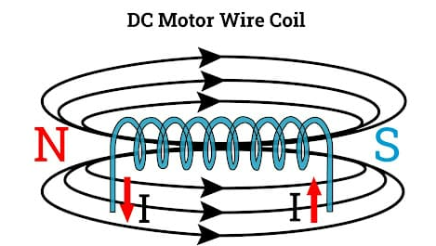
Fig : DC Motor Wire Coil
Brushes
The brushes of a DC motor provide the coils with power and are metal pieces that act like springs. On one side, they have a conductive material made of carbon. On the other side, they have a pin where the power supply is applied to the motor. The brushes are pushed by their spring action against the commutator, are held in place by the brush arms, and are directly connected to the terminals or electrical supply.
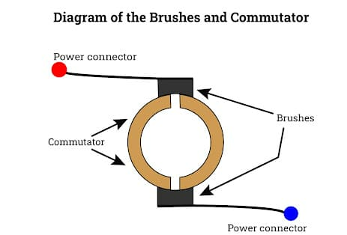
Fig : Brushes and commutator
Commutator
The commutator is made of small copper plates that are mounted on the shaft and rotate as the shaft rotates. The rotation of the rotor causes the poles of the power supply to the coils to change.
Each coil is connected to two commutator plates, which are electrically isolated from each other but connected by the coils. With positive and negative terminals connected to two commutator plates, current easily flows and an electromagnetic field is generated.
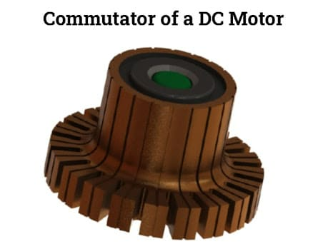
Fig : Commutator of DC Motor
4.4.3 Uses of DC Motor
DC motors are used in any number of applications since they have a high starting torque compared to induction motors. Brushed DC motors are easy to miniaturize, and they provide good rotational control as well as high efficiency. Brushless DC motors have a long life due to their lack of wear from brushes, are easy to maintain, and are noiseless.
It is easy to find DC motors since they are all around us in multiple applications and processes. DC motors have been used as a mechanical power source for over 130 years. The variations in their use run from providing power to a ceiling fan in a bedroom to supplying mechanical energy to a large printing press.
The list below provides descriptions of a few of the millions of uses for DC motors.

Diesel Electric Locomotives
In a diesel electric locomotive, combustion from the diesel engine is converted into rotational energy by the diesel engine, which is coupled with a generator that converts it to electrical energy. The converted electrical energy is fed to DC motors that are coupled with the wheels on the engine.

Electric Vehicles
Brushed DC motors are used in electric vehicles for retracting and positioning electrically powered windows. Since brushed motors tend to wear out rapidly, many electric vehicle applications use brushless motors due to their long life span and noiselessness. Brushless DC motors are used for windshield wipers and CD players. All of the recent hybrid electric vehicles depend on brushless DC motors.

Cranes
In applications with overhauling loads, it is important for the motor to have the ability to hold a full load at zero speed where mechanical brakes may not be required. In those situations, DC motors are the most cost effective and safest option. A major benefit of their use is their size and weight.

Conveyor Systems
Conveyor systems require constant speed and high torque, which makes DC motors an ideal option. As has been found with other applications, DC motors have high torque at start up and even consistent speed. Brushless DC motors are the most commonly used for conveyor applications. They are noiseless and can be easily controlled, a major requirement for conveying systems.

Ceiling Fans
Ceiling fans made with DC motors have become extremely popular. They use less power and have a rapid start up torque. The alternating current in a home or office is easily converted to DC power by a transformer, an effect that decreases the amount of power required by the fan. As with other DC motor applications, brushless DC motors are most commonly used in ceiling fans.

Pump Drives
DC motors have been the main driving force behind pumps for several decades because of their variable speed control, simple control system, high starting torque, and good transient response. For many years, pumping systems depended on brushed DC motors as their primary source of energy. The development of permanent magnet DC motors and brushless DC motors have offered a more beneficial option for pump system operations.

